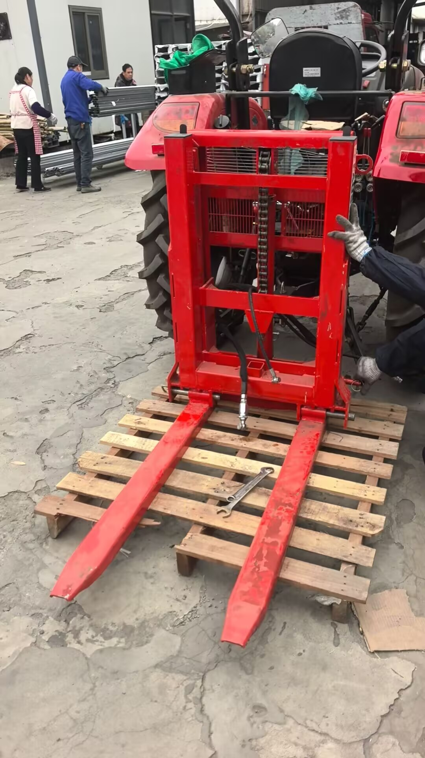

Model | MAX LOADING | LIFTTING HIGH | OVERRALL HIGH | WEIGHT | 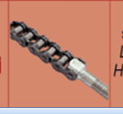 | CYLINDER
HYD700 | 700KG | 1300MM | 1250MM | 150KG | 1 | 1

